For Immediate Release
Contact: Mona Baroudi
415.615.2735
mona@monabaroudipr.com

THE SAN FRANCISCO
INTERNATIONAL HIP HOP DANCEFEST CELEBRATES 20 YEARS

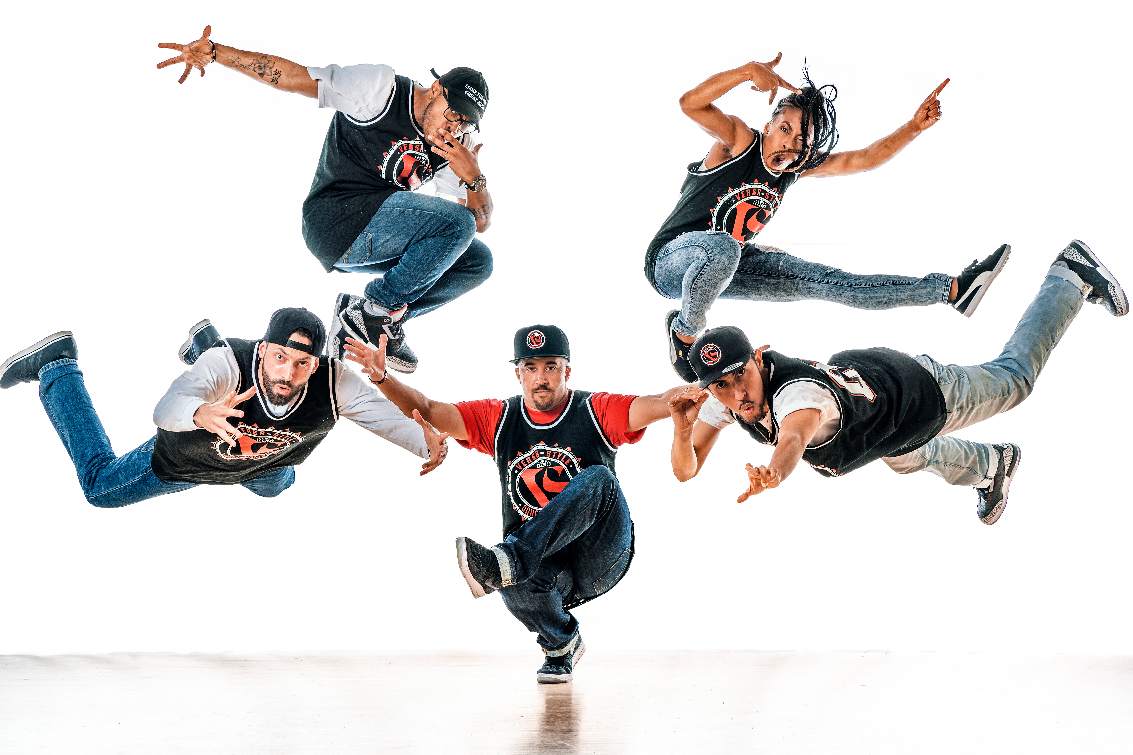
Versa-Style, photo by George Simian

November 16 - 18, 2018

Palace of Fine Arts Theatre
3301 Lyon Street, San Francisco
sfhiphopdancefest.com

“mind-blowing dance and compelling artistry” – Claudia Bauer, San Francisco Chronicle

SAN FRANCISCO, CA – September 27, 2018 – Micaya is pleased to present the 20th Anniversary of the San Francisco International Hip Hop DanceFest (SFIHHDF), featuring groundbreaking hip-hop performances from 14 dance companies from around the globe.

In 1993, dancer, choreographer, teacher, and producer Micaya began producing grassroots hip-hop dance shows in the heart of San Francisco’s Mission District. Those shows quickly sold out, and led up to the creation of the first ever SFIHHDF in 1999 at Theatre Artaud. Micaya’s vision was to move hip-hop dance from the street and studio onto a proscenium stage, and to create a festival that honored both the artistry and diversity of hip-hop dance in a non-competitive environment. Now presented at the Palace of Fine Arts Theatre, the festival attracts companies from all over the globe, and has firmly placed San Francisco on the map as a premier presenter of hip-hop dance.

Under the umbrella of hip hop, this year’s festival showcases work that draws variously from b-boying, jazz, modern, waacking, locking, krump, house, popping, and more. The 2018 festival welcomes international artists from London, Amsterdam, Paris, and Vietnam. Stateside, SFIHDDF hosts dancers from Los Angeles, Philadelphia, Murfreesboro, TN and locally from Oakland, San Francisco, San Mateo, Vacaville, and Hayward. More than 100 individuals will take the stage at the Palace of Fine Arts Theatre mixing skillfulness with artistry and storytelling.

“I am dedicating the festival this year to the Bay Area Dance Community,” says Micaya. “They were the ones who inspired me to start this Festival.”

The festival culminates this year with a 20th Anniversary Bash on Sunday, November 18 at 7:30pm at the Palace of Fine Arts Theatre. Guests will be treated to a champagne toast, short, performances, DJ, small bites, and more surprises. And following the Sunday matinee at 12pm, the festival welcomes kids onstage for the SFIHHDF Kids Freestyle Circle. The festival will also host master classes around the Bay Area.

Established in 1999 by Micaya, The San Francisco International Hip Hop DanceFest has earned an international reputation as one of the most prestigious presenters of hip-hop dance. The SFIHHDF is the first ever festival dedicated to honoring the artistry and diversity of hip-hop dance forms in a non-competitive environment. The SFIHHDF creates a convergence of global phenomena by presenting groundbreaking performances from professional dance companies from all over the globe. 2018 marks the 20th year for the SFIHHDF; presenting inspiring, electrifying and thought provoking works of art through hip hop dance forms.

The program follows (subject to change):

Program A
The Tribe (Bay Area) “The Tribe”
Bliss Dance Company (Vacaville, CA) “16 Shots”
The Rookies (Paris, France) “FreeWay part 1”
Amenti Movemeant (Netherlands) “Akasha x Amenti”
Duwane Taylor (London, England) “It’s Time to Speak”
Loyalty Dance Company (Murfreesboro, TN) “This is Wakanda!!!”
Versa-Style Dance Company (Los Angeles, CA) "Box of Hope - Part 1”
Yeah Yellow (Paris, France) “Yeah Yellow Sunshine - Part 1”
See Through Soul (Oakland, CA) “Journey Into…”
Paradox Sal (Paris, France) “Queen Blood - Part 1”

Program B
Str8jacket (San Mateo, CA) “Hackers”
Paradox Sal (Paris, France) “Queen Blood - Part 2"
Yeah Yellow (Paris, France) “Yeah Yellow Sunshine - Part 2”
Versa-Style Dance Company (Los Angeles, CA) “Box of Hope - Part 2”
The Rookies (Paris, France) “FreeWay part 2"
Loyalty Dance Company (Murfreesboro, TN) “The Return of Loyalty Dance Team”
Amenti Movemeant (Netherlands) “Anima"
Kai Rapelyea (Philadelphia, PA) “The Heart of One”
Jade Hackett (London, England) “Self Love”
re:DEFINE Dance Collective (Hayward, CA) “Blenders”

CALENDAR EDITORS PLEASE NOTE

WHAT:
Micaya presents the 20th Anniversary of the San Francisco International Hip Hop DanceFest

WHEN:
November 16 - 18, 2018

Program A
Friday, November 16 at 8pm
Sunday, November 18 at 12pm (followed by an onstage Kids Freestyle Circle)

Program B
Saturday November 17 at 8pm
Sunday November 18 at 5pm

20th Anniversary Bash
Sunday, November 18, 7:30pm (includes a champagne toast, performances, DJ, lite bites and more)

WHERE:
Palace of Fine Arts Theatre
3301 Lyon Street
San Francisco, CA 94123

TICKETS:
Single program tickets: $45-$55
20th Anniversary Bash: $25

Group Discount:
A 10% group discount is available for 10 or more tickets to the same performance.

To purchase visit www.sfhiphopdancefest.com.

